**GROUP MEMBERS**

* **ISSAM BHUKHARI(group leader)**
* **BILAL ABBASI**
* **OSAMA KHAN**
* **MAHNOOR SHAFIQUE**
* **FARZANA SHAREEFI**
* **MAWRA IQBAL**

**HOSTEL MANAGEMET SYSTEM**

**ABSTRACT**

“HOSTEL MANAGEMENT SYSTEM” is a software developed for managing various activities in the hostel. For the past few years, the number of educational institutions are increasing rapidly. Thereby the number of hostels are also increasing for the accommodation of the students studying in this institution. And hence there is a lot of strain on the person who are running the hostel and software’s are not usually used in this context. This project deals with the problems on managing a hostel and avoids the problems which occur when carried manually.

Identification of the drawbacks of the existing system leads to the designing of computerized system that will be compatible to the existing system with the system Which is more user friendly and more GUI oriented.

**Table of content:**

1. INTRODUCTION

1.1 PROBLEM DEFINITION

1.2 OBJECTIVES OF PROJECT

1.3 FUNCTIONAL REQUIREMENTS

1.4 SCOPE

2. SYSTEM ENVIRONMENT

2.1 SOFTWARE CONFIGURATION

2.2 HARDWARE CONFIGURATION

3. SYSTEM ANALYSIS

3.1 SOFTWARE TOOL USED

4. SYSTEM DESIGN

4.1 TABLE DESIGN

4.2 DATA FLOW DIAGRAM’S

4.3 ENTITY RELATIONSHIP DIAGRAM

4.4 SEQUENCE DIAGRAM

4.5 CLASS DIAGRAM

5. SYSTEM IMPLEMENTATION

5.1 QURIES AND SCREEN SHOTS

6. ADDVANTAGES AND DISADDVANTAGES

7. SYSTEM TESTING

7.1 UNIT TESTING

7.2 INTEGRATION TESTING

8. CONCLUSION

**1 INTRODUCTION**

**1.1 PROBLEM DEFINITION**

This system is designed in favor of the hostel management which helps them to save the records of the students about their rooms and other things. It helps them from the manual work from which it is very difficult to find the record of the students and the mess bills of the students, and the information of about those ones who had left the hostel. All the hostels at present are managed manually by the hostel office. The Registration form verification to the different data processing is done manually. Thus, there are a lot of repetitions which can be easily avoided. And hence there is a lot of strain on the person who are running the hostel and software’s are not usually used in this context. This project deals with the problems on managing a hostel and avoids the problems which occur when carried manually Identification of the drawbacks of the existing system leads to the designing of computerized system that will be compatible to the existing system with the system which is more user friendly. We can improve the efficiency of the system, thus overcome the drawbacks of the existing system. We design this system of the hostel management especially for the college hostel, through this they cannot require so efficient person to handle and calculate the things. This system automatically calculates all the bills and issued the notifications for those students who are against some rules.

**1.2 OBJECTIVES OF PROJECT**

This software product the hostel management to improve their services for all the students of the hostel. This also reduce the manual work of the persons in admin penal and the bundle of registers that were search when to find the information of a previous student, because through this system you can store the data of those students who had left the hostel. Through this you can check the personal profile of all the current students within few minutes the data base of the system will help you to check a particular one. The system will help you to check the mess bills of every student and the student’s hostel dues. The students of the hostel will be recognized from the ID number allocated at the room rental time. In the last this system will improve the management work in the hostel.

* To automate every activity of the manual system, which increases its throughput.
* To provide a quick response with very accurate information as and when required.
* To make the present manual system more interactive, speedy and user friendly.
* To avail any information, whatever and whenever needed.
* Reduce the cost of maintenance

**1.3 FUNCTIONAL REQUIREMENTS**

Functional Requirements There are the following main functional Requirements of our system

* Student _detail ------------------------------------------ To enter the details of the students
* Room details --------------------------------------------- To enter the details of hostel rooms
* Attendances details ------------------------------------ Maintain the student attendance detail.
* Mess _details -------------------------------------------- To keep the record of

**1.4 SCOPE**

Managing a hostel is a tedious task that needs a lot of supervision and can be time consuming. The hostel management system is a dynamic as well as practical approach as it makes managing the boarding and other related facilities a lot easier. This Online Hostel management system will reduce the burden on the administration staff and will simplify roles and responsibilities as most of the manual tasks and mundane paperwork will be done through the online system.

This Hostel Management system will ensure the record management and flawless execution of administrative tasks such as managing:

* hostel applications
* registration forms
* allotment of rooms
* fees management
* mess payment management
* visitors record
* student expenses
* hostel furniture
* hostel block
* hostel floor
* ground record

and easy communication with students and parents. The hostel administration team will access all the hostel data and will be able to always manage the workflow from their device, ensuring that updates will be made in real time and notifications to parents will also be sent in real time. It will also help securely store and manage the data of the students, allowing access to a few authorized staff members only. The above all the records will be safe with password which will need authentic login.

**2. SYSTEM ENVIRONMENT**

**2.1 SOFTWARE CONFIGURATION**

Operating System : Windows 10

Database : MYSQL

**2.2 HARDWARE CONFIGURATION**

RAM : 32 GB

Hard Disk : 1 TB

**3. SYSTEM ANALYSIS**

**3.1 SOFTWARE TOOL USED**

**MYSQL**

MySQL ("My S-Q-L", officially, but also called "My Sequel") is (as of July 2013) the world's second most widely used open-source relational database management system (RDBMS). It is named after co-founder Michael Wideners daughter; The SQL phrase stands for Structured Query Language. The MySQL development project has made its source code available under the terms of the GNU General Public License, as well as under a variety of proprietary agreements. MySQL was owned and sponsored by a single for-profit firm, the Swedish company MySQL AB, now owned by Oracle Corporation. MySQL is a popular choice of database for use in web applications and is central components of the widely used LAMP open-source web application software stack (and other 'AMP' stacks). LAMP is an acronym for "Linux, Apache, MySQL, Perl/PHP/Python." Free-software-open-source projects that require a full-featured database management system often use MySQL. For commercial use, several paid editions are available, and offer additional functionality.

**4. SYSTEM DESIGN**

**4.1 TABLE DESIGN**

The following are the tables that are involved in the proposed system.

***1.HOSTEL LOGIN***

|  |  |
| --- | --- |
| **FIELD NAME** | **DATA TYPE** |
| student id | INT |
| student name | VARCHAR |
| student password | VARCHAR |
| student status | VARCHAR |

***2.HOSTEL***

|  |  |
| --- | --- |
| **FIELD NAME** | **DATA TYPE** |
| Hostel id (primary key) | INT |
| No of rooms | INT |
| No of students | INT |
| Location | VARCGAR |

***3.HOSTEL FLOOR***

|  |  |
| --- | --- |
| **FIELD NAME** | **DATA TYPE** |
| Floor id (primary key) | INT |
| Floor number | INT |
| Floor name | VARCHAR |
| Floor status | VARXHAR |

***4.HOSTEL BLOCK***

|  |  |
| --- | --- |
| **FIELD NAME** | **DATA TYPE** |
| Block id (primary key) | **INT** |
| Block number | **INT** |
| Block name | **VARCHAR** |
| Block status | **VARCHAR** |

***5.HOSTEL ROOM***

|  |  |
| --- | --- |
| **FIELD NAME** | **DATA TYPE** |
| Room id (primary key) | INT |
| Room number | INT |
| Room block name | VARCHAR |
| Room floor name | VARCHAR |
| Room capacity | VARCHAR |
| Room status | VARCHAR |
| Hostel ID (foreign key) | INT |

***6.HOSTEL GROUND***

|  |  |
| --- | --- |
| **FIELD NAME** | **DATA TYPE** |
| Ground id (primary key) | INT |
| Ground name | VARCHAR |
| Ground block name | VARCGAR |
| Ground rent | FLOAT |
| Ground status | VARCHAR |
| Ground timing | VARCHAR |
| Hostel id (foreign key) | INT |

***7.HOSTEL MESS***

|  |  |
| --- | --- |
| **FIELD NAME** | **DATA TYPE** |
| Mess-in charge id (primary key) | INT |
| Monthly expenses | FLOAT |
| Breakfast timing | VAR HAR |
| Launch timing | VARCHAR |
| Dinner timing | VARCHAR |
| Hostel Id (foreign key) | INT |

***8.HOSTEL FURNITURE***

|  |  |
| --- | --- |
| **FIELD NAME** | **DATA TYPE** |
| Furniture id (primary key) | INT |
| Furniture type | VARCHAR |
| Room no | INT |
| Hostel id (foreign key) | INT |

***9.HOSTEL ATTENDENCE***

|  |  |
| --- | --- |
| **FIELD NAME** | **DATA TYPE** |
| Student id (primary key) | INT |
| Student name | VARCHAR |
| Attendance date | DATE |
| Attendance time | VARCHAR |
| Attendance status | VARCHAR |

***10.HOSTEL VISITOR***

|  |  |
| --- | --- |
| **FIELD NANE** | **DATA TYPE** |
| Visitor id (primary key) | INT |
| Visitor name | VARCHAR |
| Visitor phone number | VARCHAR |
| Visitor relation | VARCHAR |
| Visit date | DATE |
| Entry time | VARCHAR |
| Leaving time | VARCHAR |

***11.HOSTEL STAAF***

|  |  |
| --- | --- |
| **FIELD NAME** | **DATA TYPE** |
| Staff id (primary key) | INT |
| Staff name | VARCHAR |
| Staff address | VARCHAR |
| Staff salary | FLOAT |
| Staff phone no | VARCHAR |
| Staff designation | VARCHAR |
| Hostel id (foreign key) | INT |

***12.STUDENT INFORMATION***

|  |  |
| --- | --- |
| **FIELD NAME** | **DATA TYPE** |
| Student id (PRIMARY KEY) | INT |
| Student name | VARCHAR |
| Student gender | VARCHAR |
| Student Dob | VARCHAR |
| Student address | VARCHAR |
| Student contact number | VARCHAR |
| Student email | VARCHAR |
| Student father name | VARCHAR |
| Parents contact number | VARCHAR |
| Student department | VARCHAR |
| Hostel id (foreign key) | INT |
| Room id (foreign key) | INT |

***13.STUDENT EXPENSES***

|  |  |
| --- | --- |
| **FIELD NAME** | **DATA TYPE** |
| Student id | INT |
| Student name | VARCHAR |
| Room number | VARCHAR |
| Room rent | FLOAT |
| Room mess | FLOAT |
| Expenses Date | DATE |
| Other expenses | FLOAT |
| Sud fine | FLOAT |
| Total expenses | FLOAT |

***14.STUDENT FEE***

|  |  |
| --- | --- |
| **FIELD NAME** | **DATA TYPE** |
| Student id (primary key) | INT |
| Student name | VARCHAR |
| Fee monthly | FLOAT |
| Fee status | VARCHAR |
| Remaining dues | FLOAT |
| Mess fee | FLOAT |
| Hostel id (foreign key) | INT |

**4.2 DATA FLOW DIAGRAM’S**

***LEVEL 0***

***LEVEL 1***

***LEVEL 2***

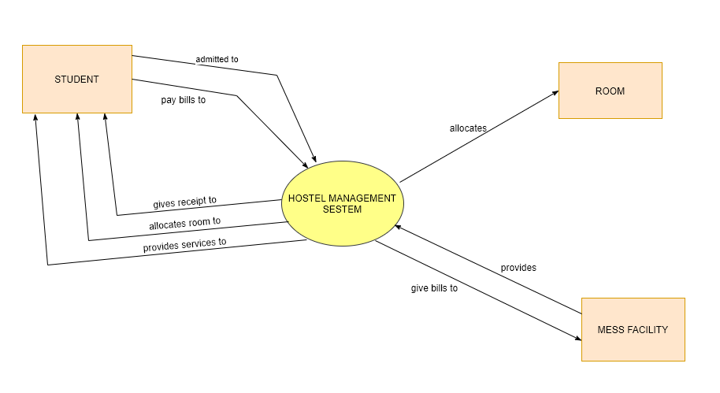

**4.3 ENTITY RELATIONSHIP DIAGRAM**

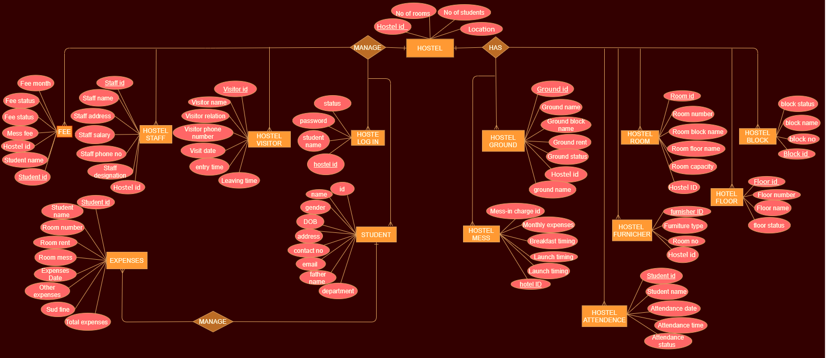

**4.4 SEQUENCE DIAGRAM**

**4.5 CLASS DIAGRAM**

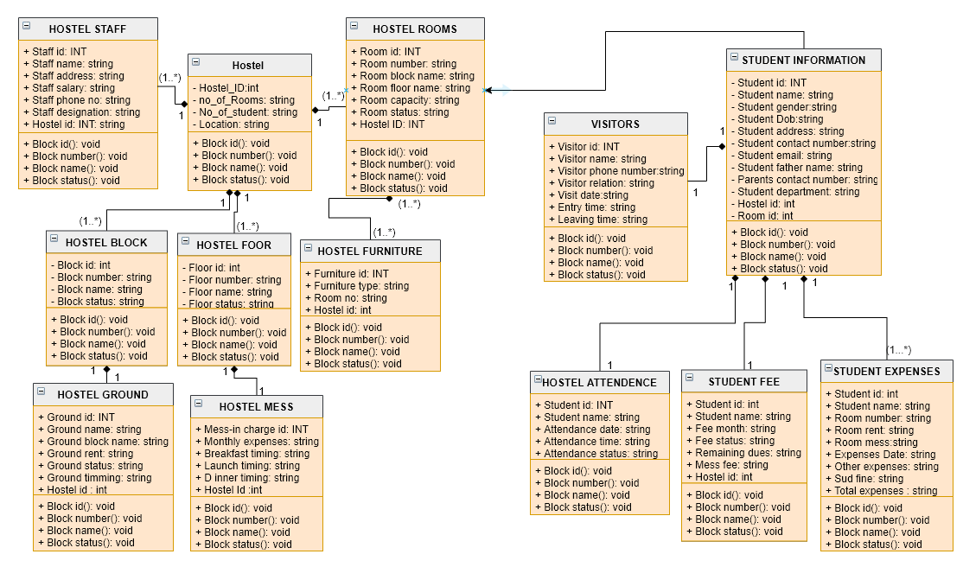

**5. SYSTEM IMPLEMENTATION**

**5.1 QUERIES and SCREEN SHOTS**

***1.hostel login table***

create database HostelManagement;

use HostelManagement;

create table Hostel_login (

studentid int,

studentname varchar (70),

studentpassword varchar (90),

studentstatus varchar(80),

Primary key (studentid));

insert into Hostel_login(studentid,studentname,studentpassword,studentstatus)

values

(21,'hassan','hassan123','active'),

(22,'noman','nomi3','active'),

(23,'asad','pakistan786','non active');

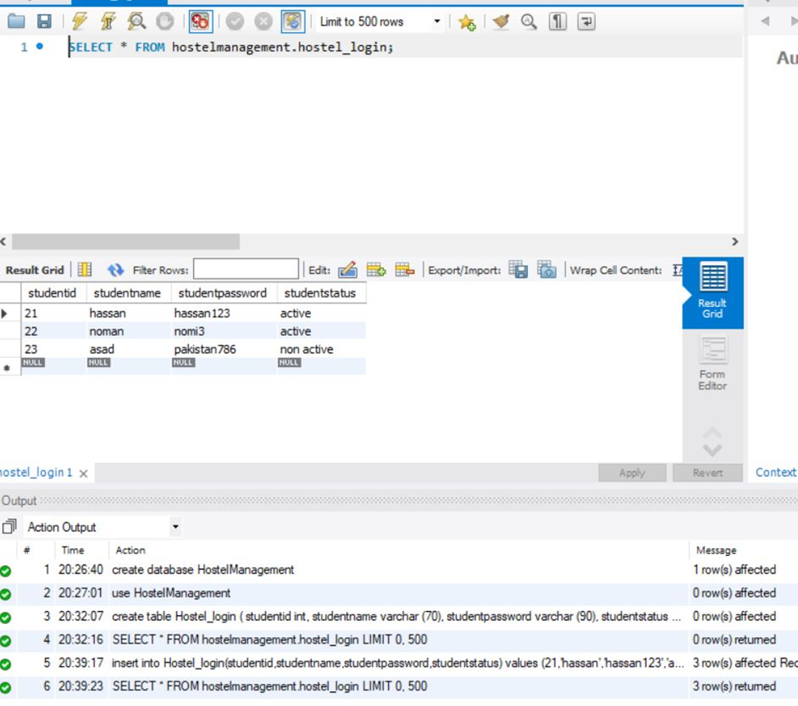

***2.hostel table***

create table Hostel(

Hostelid int,

Noofrooms int,

Noofstudents int,

Location varchar(90),

primary key (Hostelid));

insert into Hostel(Hostelid,Noofrooms, Noofstudents,Location)

values

(321,25,50,'complex abbotabbad'),

(322,30,60,'Mansehra'),

(323,15,40,'Damtorh');

Select * from Hostel;

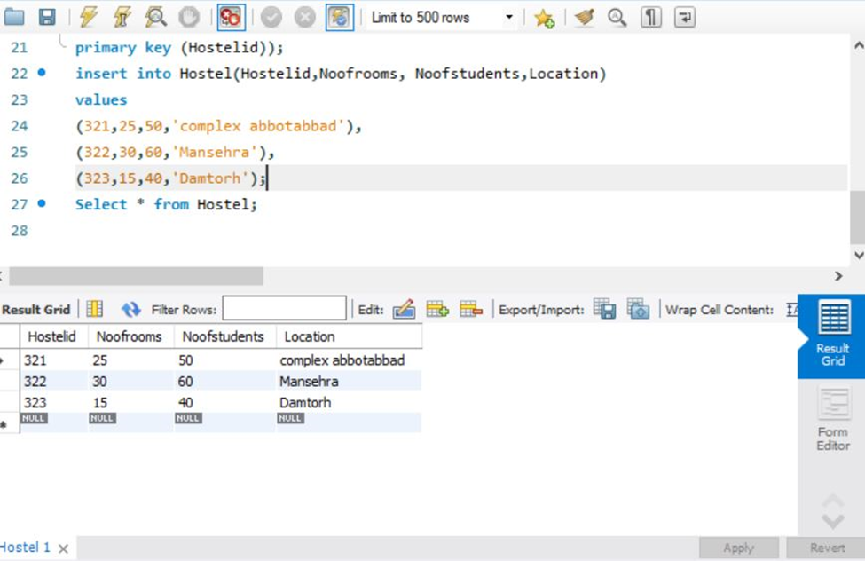

***3.hostl floor table***

create table Floor (

Floorid int,

Floornumber int ,

Floorname varchar(90) ,

Floorstatus varchar(90),

primary key (Floorid));

insert into Floor(Floorid,Floornumber,Floorname ,Floorstatus)

values

(221,5,'shaheen','Availble'),

(222,6,'iqbal','Availble'),

(223,7,'quid','Not Availble');

Select * from Floor;

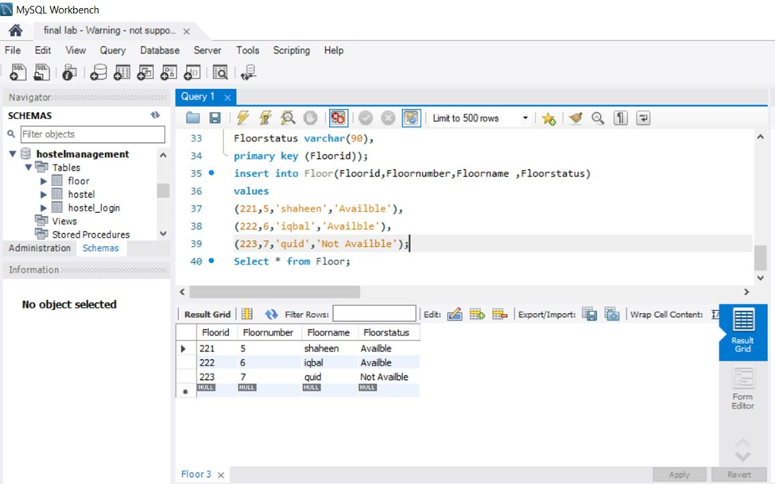

***4.hostel block table***

create table HostelBlock(

Blockid int,

Blocknumber int,

Blockname varchar(70),

Blockstatus varchar(70),

Primary key (Blockid));

insert into HostelBlock(Blockid ,Blocknumber ,Blockname ,Blockstatus)

values

(231,1,'salman','Availble'),

(232,2,'iqbal','Not Availble'),

(233,3,'quid','Availble');

select * from HostelBlock;

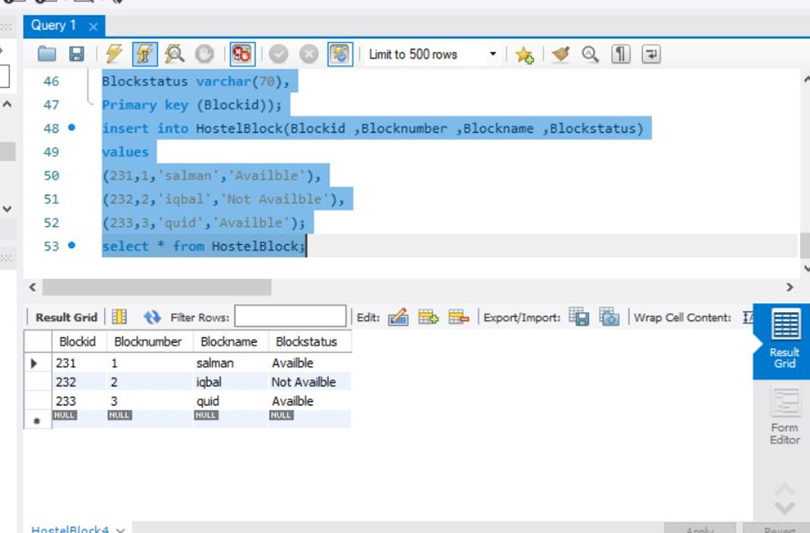

***5.hostel room table***

Create table HostelRoom(

Hostelid int,

Room_id int,

Room_number int,

Room_block_name varchar (90),

Room_floor_name varchar (90),

Room_capacity varchar (90),

Room_status varchar (90),

primary key (Room_id),

Foreign key (Hostelid) REFERENCES Hostel(Hostelid));

insert into HostelRoom(Hostelid,Room_id,Room_number,Room_block_name ,Room_floor_name ,Room_capacity ,Room_status)

values

(321,51,44,'salman','shaheen','2 Seater', 'Availble'),

(322,52,45,'iqbal','iqbal','single Seater','Not Availble'),

(323,54,46,'quid','quaid','3 Seater','Availble');

select * from HostelRoom;

**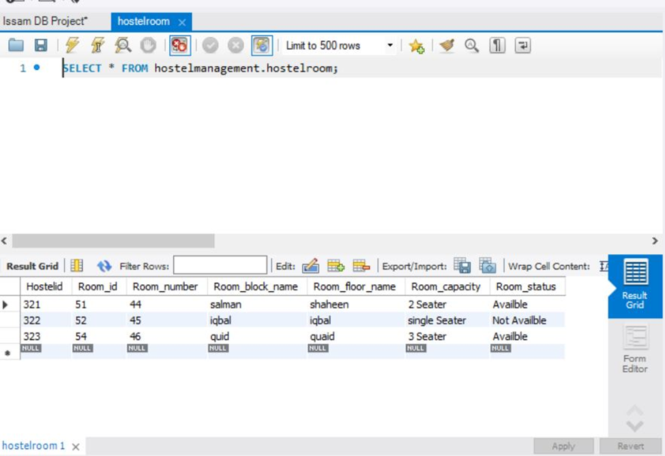*6.hostel ground table***

Create table Ground(

Hostelid int,

Groundid int,

Groundname varchar (70),

Groundblockname varchar(80),

Groundrent float,

Groundstatus Varchar(80),

Groundtimming varchar(90),

primary key (Groundid),

Foreign key (Hostelid) REFERENCES Hostel(Hostelid));

insert into Ground(Hostelid,Groundid,Groundname,Groundblockname,Groundrent,Groundstatus,Groundtimming)

values

(321,1,'football','salman',5000,'Availble','9:00 AM to 4:00 PM'),

(322,2,'cricket','iqbal',10000,'Not Availble','9:00 AM to 8:00 PM'),

(323,3,'hockey','quaid',12000,'Availble','11:00 AM to 3:00 PM');

select * from Ground;

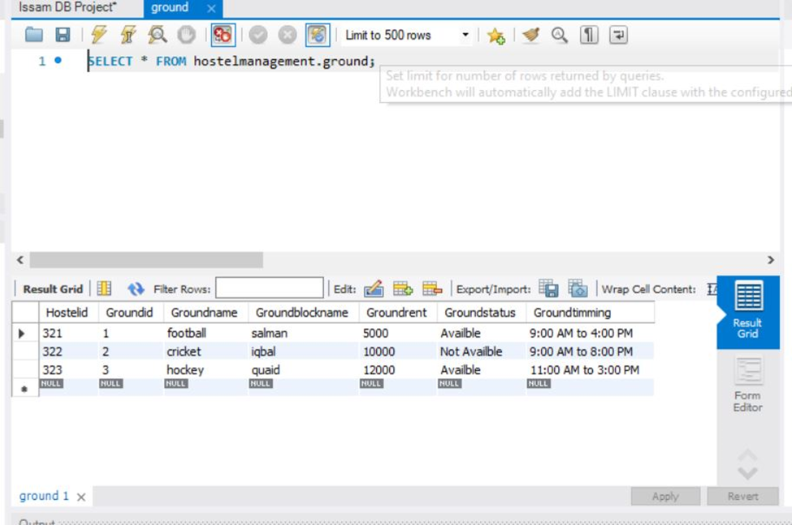

***7.Hostel mess table***

create table Mess(

Hostelid int,

Mess_incharge_id int,

Monthlyexpences float,

Breakfast_timing Varchar(90),

Launch_timing varchar (90),

Dinner_timing Varchar (90),

primary key (Mess_incharge_id),

Foreign key (Hostelid) REFERENCES Hostel(Hostelid));

insert into Mess(Hostelid,Mess_incharge_id,Monthlyexpences,Breakfast_timing,Launch_timing,Dinner_timing)

values

(321,12,525.50,'9:00 AM to 11:00 AM','12:00 PM to 2:00 PM','9:00 PM to 10:00 PM'),

(322,13,1000,'9:00 AM to 10:00 AM','12:00 PM to 3:00 PM','7:00 PM to 8:00 PM'),

(323,14,7000,'8:00 PM to 10:00 AM','12:00 PM to 2:30 PM','8:00 PM to 9:45 PM');

select * from Mess;

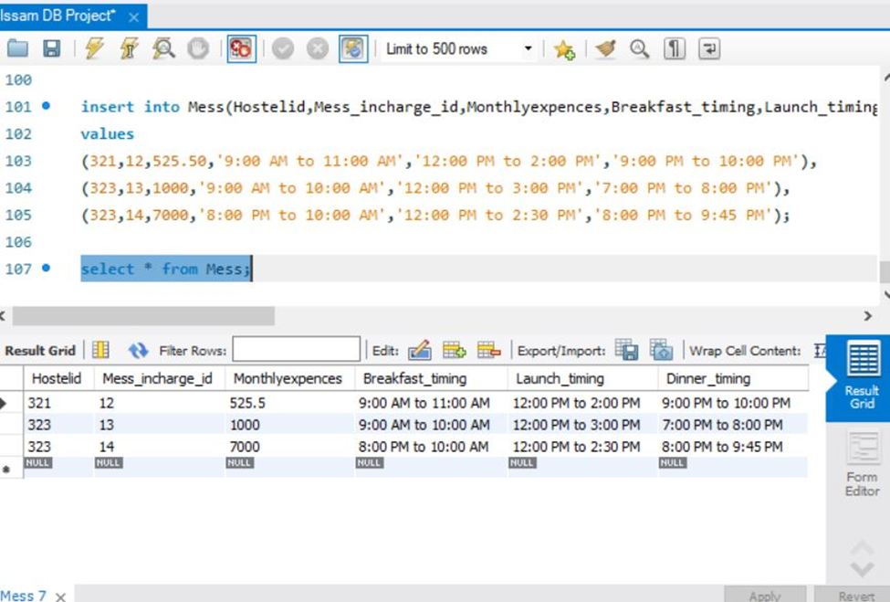

***8.Hostel furniture table***

Hostel furniture tabke

create table furniture(

Hostelid int,

Furniture_id int ,

Furniture_type varchar(90),

Room_No int,

primary key (Furniture_id),

Foreign key (Hostelid) REFERENCES Hostel(Hostelid));

insert into furniture(

Hostelid,

Furniture_id,

Furniture_type,

Room_No)

values

(321,25,'Metras',51),

(322,30,'Metras',52),

(323,15,'Bed',54);

select * from furniture;

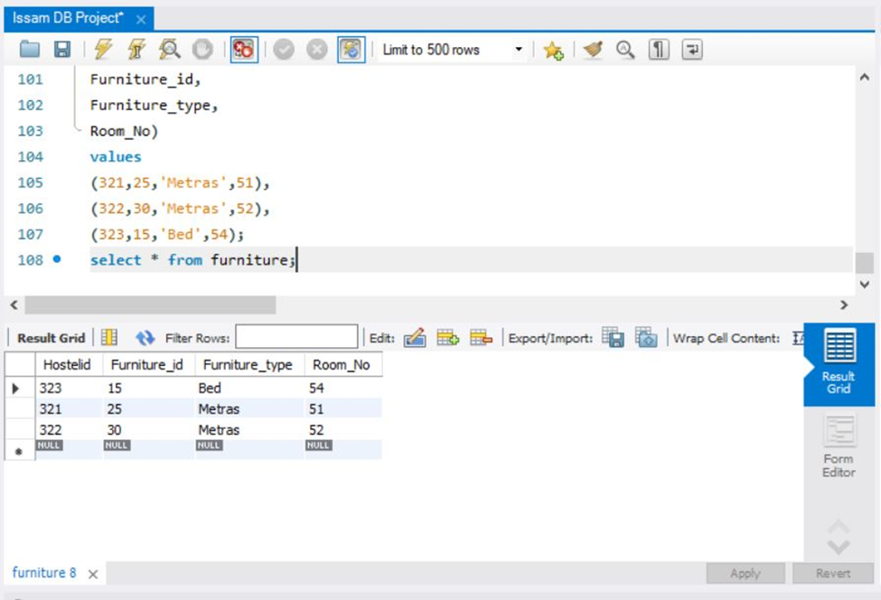

***9.hostel attendance table***

create table attendance(

Studentid int,

Student_name varchar(90),

Attendance_date date,

Attendance_time Varchar(90),

Attendance_status varchar (90),

primary key (Studentid));

insert into attendance(

Studentid,

Student_name,

Attendance_date,

Attendance_time,

Attendance_status)

values

(1,'issam','2020-5-24','9:00 AM','present'),

(2,'mahnoor','2020-5-24','8:00 AM','present'),

(3,'bilal','2020-5-24','8:45 AM','Absent');

select * from attendance;

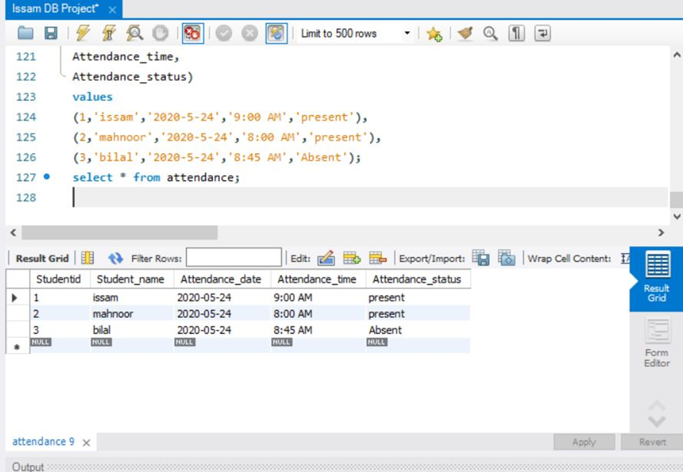

***10.hostel visitor table***

create table visitor(

Visitorid int,

Visitorname varchar (90),

Visitorphonenumber varchar(90),

Visitorrelation varchar(90),

Visitdate date,

Entrytime varchar (90),

Leavingtime varchar(90),

primary key (Visitorid));

insert into visitor(

Visitorid,

Visitorname,

Visitorphonenumber,

Visitorrelation,

Visitdate,

Entrytime ,

Leavingtime)

values

(1,'hassan','03070751356','brother','2020-5-24','4:00 PM','4:30 PM'),

(2,'abbasi','03493004173','father','2020-6-4','3:00 PM','3:30 PM'),

(3,'bukhari','03100917499','brother','2020-8-19','2:00 PM','3:00 PM');

Select * from visitor;

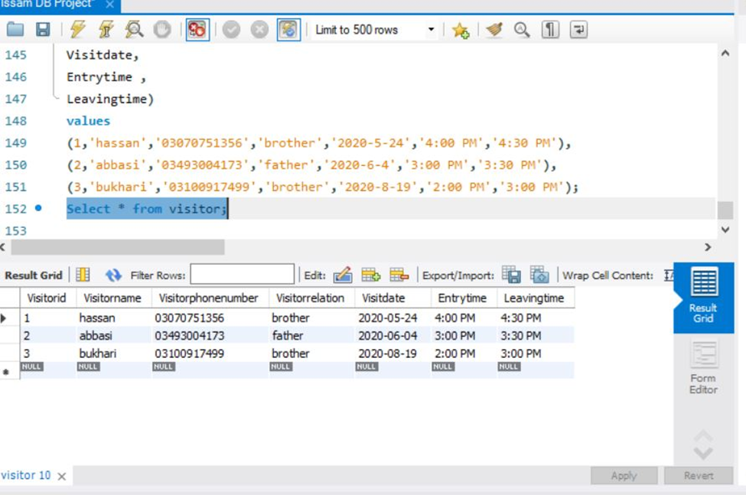

***11.hodtel staff table***

create table staff(

Hostelid int,

Staffid int,

Staffname varchar(90),

Staffaddress varchar(90),

Staffsalary float,

Staffphoneno varchar(90),

Staffdesignation varchar(90),

primary key (Staffid),

Foreign key (Hostelid) REFERENCES Hostel(Hostelid));

insert into staff(

Hostelid,

Staffid,

Staffname,

Staffaddress,

Staffsalary,

Staffphoneno,

Staffdesignation)

values

(321,1,'aman','abbotabbad',50000,'03159577102','clerk'),

(322,2,'salman','peshawar',60000,'03100917799','warden'),

(323,3,'haris','multan',70000,'03159777112','manager');

select * from staff;

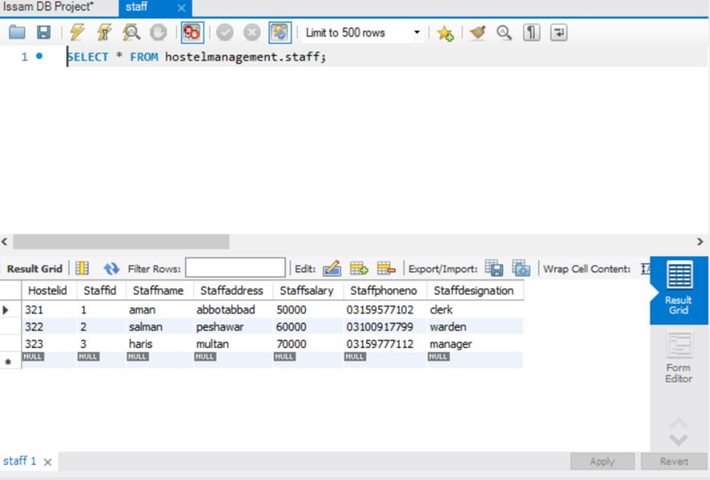

***12.student table***

create table Student_information(

Hostelid int,

Room_id int,

Studentid int,

Studentname varchar(90),

Studentgender varchar(90),

StudentDob varchar(90),

Studentaddress varchar(90),

Studentcontactnumber varchar(90),

Studentemail varchar(90),

Studentfathername varchar(90),

Parentscontactnumber varchar(90),

Studentdepartment varchar(90),

primary key (Studentid),

Foreign key (Hostelid) REFERENCES Hostel(Hostelid),

foreign key (Room_id) REFERENCES HostelRoom(Room_id));

insert into Student_information(

Hostelid,

Room_id,

Studentid,

Studentname,

Studentgender,

StudentDob,

Studentaddress,

Studentcontactnumber,

Studentemail,

Studentfathername,

Parentscontactnumber,

Studentdepartment)

values

(321,51,44,'salman','male','2000-6-4', 'lahore','03129877102','salman@gmail.com','bukhari','03159567187','physics'),

(322,52,45,'iqbal','male','1999-6-4','multan','03169567102','iqbal12@yahoo.com','syed','03099567165','biology'),

(323,54,46,'hassan','male','1998-6-4','pindhi','03119557302','hassan32@hotmail.com','iqbal','03169567155','databse');

Select * From Student_information;

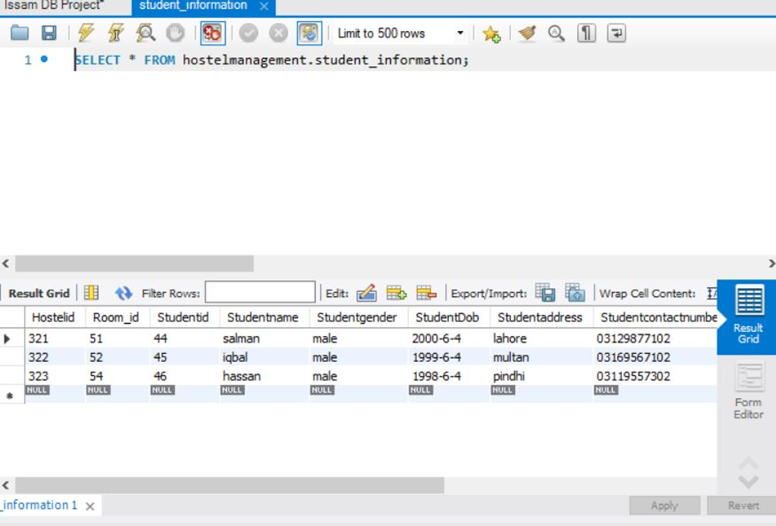

***13.student expenses table***

create table Student_Expenses(

Studentid int,

Studentname varchar (90),

Roomnumber varchar (90),

Roomrent float,

Roommess float,

ExpensesDate varchar (90),

Otherexpenses float,

Studentfine float,

Totalexpenses float,

primary key (Studentid));

insert into Student_Expenses(

Studentid,

Studentname,

Roomnumber,

Roomrent,

Roommess,

ExpensesDate,

Otherexpenses,

Studentfine,

Totalexpenses)

Values

(32,'noman','5D',5000,3500,'2020-6-4',7600.65,600,16700.65),

(33,'asad','6C',4000,3500,'2020-12-7',6600,600,14700),

(34,'salman','9E',5500,3500,'2020-8-8',7000,1000,17000);

select * from Student_Expenses;

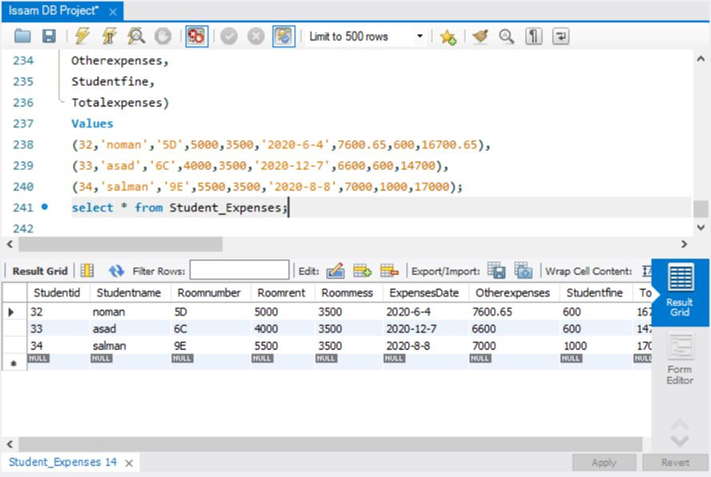

***14.student fee table***

create table student_Fee(

Hostelid int,

Studentid int,

Studentname varchar(80),

Feemonthly float,

Feestatus varchar(80),

Remainingdues float,

Messfee float,

primary key (Studentid),

Foreign key (Hostelid) REFERENCES Hostel(Hostelid));

insert into student_Fee(

Hostelid,

Studentid,

Studentname,

Feemonthly,

Feestatus,

Remainingdues,

Messfee)

values

(321,1,'aman',27000,'Paid',67000,3500),

(322,2,'salman',26000,'UnPaid',68000,3000),

(323,3,'sonu',37000,'Paid',57000,4000);

select * from student_Fee;

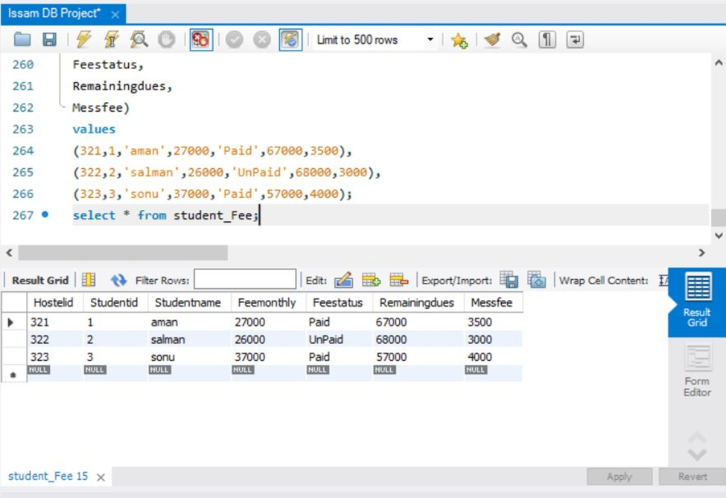

**6. ADDVANTAGES AND DISADDVANTAGES**

**ADVANTAGES**

* Advantages of using online hostel management is that it takes less time and effort consumable.
* It makes the process of updating the data fast.
* It secures data of the students/high security level.
* It reduces the manual work of the management.
* It provides us with more consistent data.
* Data redundancy can be removed to some extent.
* We can easily back up our data.
* It also enhances the educational reputation of the institution.

**DISADVANTAGES**

The number of educational institutions has been growing rapidly in recent years. And thus, the individual who runs the hostel has a lot of tension, and computer programmers are not typically used in this sense. The unique project tackles the concern in the administration of a hostel and eliminates the issue that arise when it is manually carried out. The recognition of current systems disadvantages leads to the creation of a computerized system that is consistent with the system.

**7. SYSTEM TESTING**

**7.1 UNIT TESTING**

The software units in a system are modules and routines that are assembled and integrated to perform a specific function. Unit testing focuses first on modules, independently of one another, to locate errors. This enables, to detect errors in coding and logic that are contained within each module. This testing includes entering data and ascertaining if the value matches to the type and size supported by java. The various controls are tested to ensure that each performs its action as required.

**7.2 INTEGRATION TESTING**

Data can be lost across any interface, one module can have an adverse effect on another, sub functions when combined, may not produce the desired major functions. Integration testing is a systematic testing to discover errors associated within the interface. The objective is to take unit tested modules and build a program structure. All the modules are combined and tested as a whole. Here the Server module and Client module options are integrated and tested. This testing provides the assurance that the application is well integrated functional unit with smooth transition of data.

**8. CONCLUSION**

Hostel Management is a user-friendly and Customization software for student Hostel. Hostel management system has been developed to manage and automate the over-all processing of any large student hostel. management system project can manage hostel rooms, student records and room allocation process etc. Hostel Management System is a user-friendly and customize software for providing support for hostel admin.

This project is a very flexible software, and it can be upgraded according to the individual hostel needs in the future.

**TASK PERFORM BY EACH GROUP MEMBER**

***MAVRA IQBAL***

* **Login table + requirements and advantages and disadvantages of the system**

***FARZANA SHAREEFI***

* **Hostel table + purpose of the system**

***OSAMA KHAN***

* **Hostel floor table + hostel block table + scope of the system**

***BILAL ABBASI***

* **Hostel room table + hostel ground table**

***MAHNOOR SHAFIQ***

* **Hostel mess table + hostel furniture table + ERD**

***SEYD ISSAM BUKHARI***

* **Attendance table + hostel staff table + visitor table + student information table + student expenses table + fee table**